VAISHNAVI E 231901059
EXERCISE 7
Secure Network Architecture

AIM:
Learn about and implement security best practices for network environments.
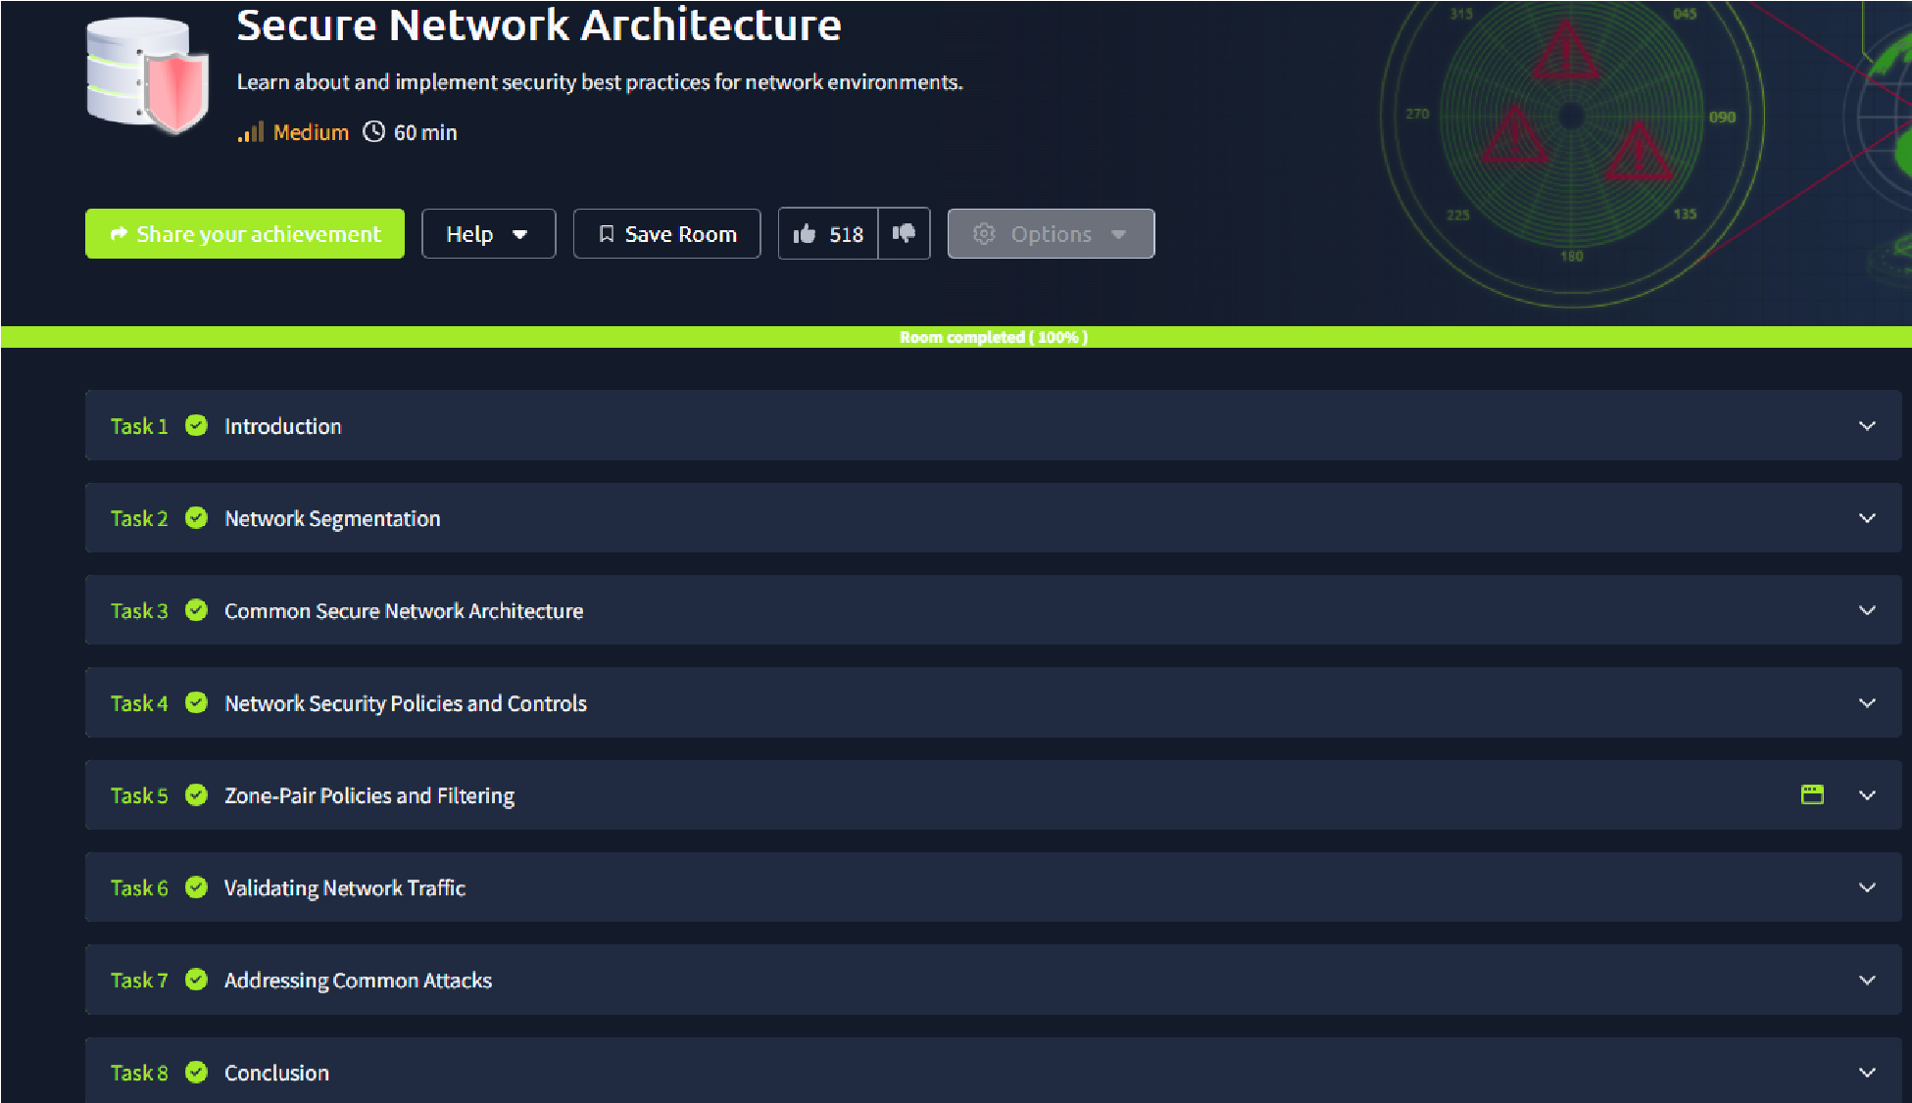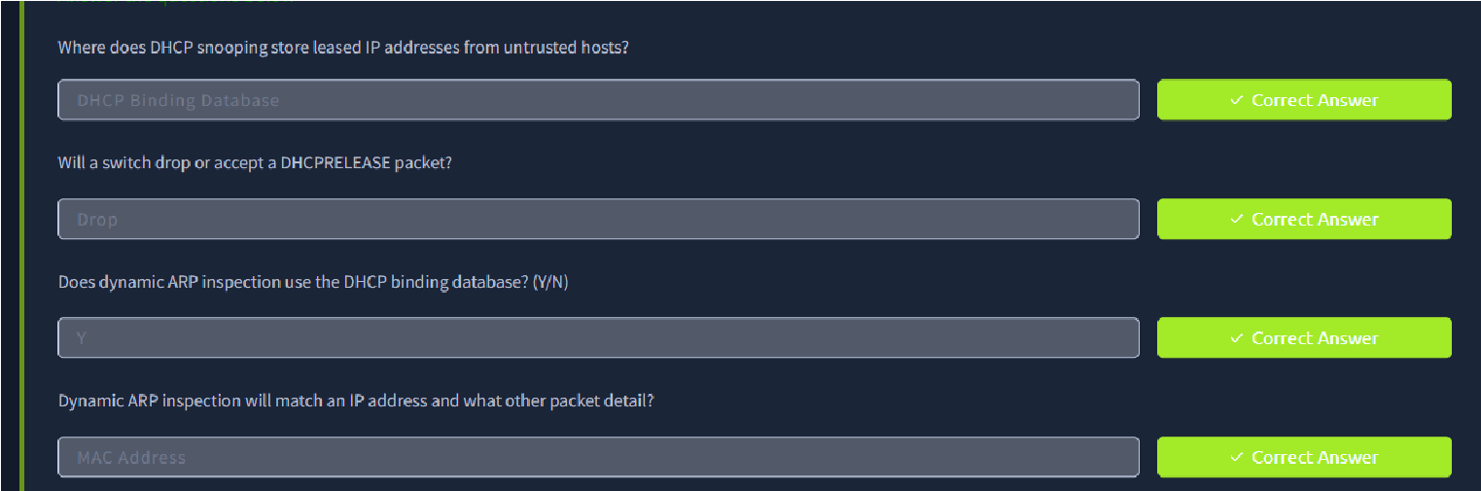

RESULT:
Designed a secure network architecture with firewalls, intrusion detection systems, and encrypted communication channels to mitigate cyber threats.

